DATA CATALOG
AIONICS HSE DATA WAREHOUSE PROJECT
Gold Layer Data Catalog
The Gold layer presents the cleaned Silver data in a star-schema structure designed for reporting, dashboards, and HSE analysis. The dimension views provide descriptive context, while the fact view stores event-level measures and the keys used to relate each event to its dimensions.
View | Type | Grain | Record Key
gold.dim_calendar | Dimension | One row per calendar date | calendar_key
gold.dim_cause_reference | Dimension | One row per cause reference record | cause_reference_key
gold.dim_equipment | Dimension | One row per equipment record | equipment_key
gold.dim_personnel | Dimension | One row per personnel record | personnel_key
gold.dim_sites | Dimension | One row per operating site | site_key
gold.dim_work_activities | Dimension | One row per work activity | work_activity_key
gold.fact_event_records | Fact | One row per HSE event record | event_record_key
Design note: The Gold layer is implemented as views. The calendar dimension uses a dynamically generated ROW_NUMBER() key, while the other dimension keys are exposed from the cleaned identifiers already available in Silver.
1. gold.dim_calendar
Purpose: Provides calendar attributes for time-based HSE analysis.
Grain: One row represents one calendar date.
Column | Data Type | Key Type | Description
calendar_key | BIGINT | Dimension Key | Unique analytical key generated for each calendar date.
date_id | INT | Business Key | Date identifier in YYYYMMDD format.
full_date | DATE | Attribute | Actual calendar date.
day_name | VARCHAR(50) | Attribute | Name of the day, such as Monday or Tuesday.
day_of_week | INT | Attribute | Numeric weekday value where Monday = 1.
week_of_year | INT | Attribute | ISO week number for the date.
month_number | INT | Attribute | Calendar month number from 1 to 12.
month_name | VARCHAR(50) | Attribute | Calendar month name.
quarter | INT | Attribute | Calendar quarter from 1 to 4.
year | INT | Attribute | Calendar year.
is_weekend | INT | Attribute / Flag | Indicates whether the date is a weekend: 1 = Yes, 0 = No.
2. gold.dim_cause_reference
Purpose: Provides standardized immediate and root-cause classifications for HSE events.
Grain: One row represents one cause reference record.
Column | Data Type | Key Type | Description
cause_reference_key | INT | Dimension Key | Unique identifier for the cause reference record.
immediate_cause_category | VARCHAR(80) | Attribute | High-level category of the immediate cause.
immediate_cause | VARCHAR(100) | Attribute | Specific immediate cause associated with an event.
root_cause_category | VARCHAR(100) | Attribute | High-level category of the underlying root cause.
root_cause | VARCHAR(80) | Attribute | Specific underlying root cause.
human_factor_flag | INT | Attribute / Flag | Indicates whether a human factor contributed: 1 = Yes, 0 = No.
equipment_factor_flag | INT | Attribute / Flag | Indicates whether equipment contributed: 1 = Yes, 0 = No.
management_system_factor_flag | INT | Attribute / Flag | Indicates whether a management-system factor contributed: 1 = Yes, 0 = No.

3. gold.dim_equipment
Purpose: Provides equipment characteristics for analysis of HSE events involving assets.
Grain: One row represents one equipment record.
Column | Data Type | Key Type | Description
equipment_key | INT | Dimension Key | Unique identifier for an equipment record.
asset_id | NVARCHAR(80) | Attribute | Operational asset identifier.
asset_type | VARCHAR(80) | Attribute | Type or category of equipment.
criticality | VARCHAR(80) | Attribute | Operational criticality classification of the equipment.
install_year | INT | Attribute | Year the equipment was installed.
asset_age_years | INT | Attribute | Equipment age in years.
maintenance_status | VARCHAR(80) | Attribute | Current maintenance condition or status.
inspection_status | VARCHAR(80) | Attribute | Current inspection status.
home_site_id | INT | Attribute | Identifier of the equipment's normal operating site.

4. gold.dim_personnel
Purpose: Provides personnel characteristics for workforce-related HSE analysis.
Grain: One row represents one personnel record.
Column | Data Type | Key Type | Description
personnel_key | INT | Dimension Key | Unique identifier for the personnel record.
employee_id | NVARCHAR(80) | Attribute | Employee or contractor identifier.
employment_type | VARCHAR(80) | Attribute | Identifies whether the person is an employee or contractor.
contractor_company | VARCHAR(100) | Attribute | Contractor company where applicable.
department | VARCHAR(80) | Attribute | Department associated with the person.
job_title | VARCHAR(80) | Attribute | Personnel job title.
age_group_code | VARCHAR(80) | Attribute | Categorical code representing the person's age group.
years_experience | FLOAT | Attribute / Measure | Number of years of work experience.
training_status | VARCHAR(80) | Attribute | Current training or compliance status.

5. gold.dim_sites
Purpose: Provides geographic and operational characteristics of HSE operating sites.
Grain: One row represents one operating site.
Column | Data Type | Key Type | Description
site_key | INT | Dimension Key | Unique identifier for the operating site.
site_code | NVARCHAR(80) | Attribute | Operational code assigned to the site.
site_name | VARCHAR(100) | Attribute | Name of the operating site.
country | VARCHAR(80) | Attribute | Country where the site is located.
region | VARCHAR(80) | Attribute | Geographic region of the site.
facility_type | VARCHAR(80) | Attribute | Type of facility.
operation_type | VARCHAR(80) | Attribute | Main type of operation performed at the site.
risk_classification | VARCHAR(80) | Attribute | HSE risk classification assigned to the site.

6. gold.dim_work_activities
Purpose: Provides work-activity and risk characteristics associated with HSE events.
Grain: One row represents one work activity.
Column | Data Type | Key Type | Description
work_activity_key | INT | Dimension Key | Unique identifier for the work activity.
activity_category | VARCHAR(80) | Attribute | High-level work activity category.
activity_name | VARCHAR(80) | Attribute | Specific activity being performed.
work_type | VARCHAR(80) | Attribute | Indicates whether the work is routine or non-routine.
shift | VARCHAR(80) | Attribute | Work shift associated with the activity.
permit_required | VARCHAR(80) | Attribute / Flag | Indicates whether a permit is required: Yes or No.
high_risk_activity | VARCHAR(80) | Attribute / Flag | Indicates whether the activity is classified as high risk: Yes or No.
risk_level | VARCHAR(80) | Attribute | Risk level associated with the work activity.

7. gold.fact_event_records
Purpose: Central fact view containing HSE event measures and links to the analytical dimensions.
Grain: One row represents one HSE event record.
Column | Data Type | Key Type | Description
event_record_key | INT | Fact Key | Unique identifier for each HSE event record.
event_id | NVARCHAR(50) | Business Identifier | Human-readable HSE event identifier.
calendar_key | BIGINT | Foreign Key | Links the event to the calendar dimension.
site_key | INT | Foreign Key | Links the event to the operating-site dimension.
personnel_key | INT | Foreign Key | Links the event to the personnel dimension.
equipment_key | INT | Foreign Key | Links the event to the equipment dimension.
work_activity_key | INT | Foreign Key | Links the event to the work-activity dimension.
cause_reference_key | INT | Foreign Key | Links the event to the cause-reference dimension.
event_type | VARCHAR(100) | Degenerate Attribute | Standardized classification of the HSE event.
severity_class | VARCHAR(50) | Degenerate Attribute | Severity classification assigned to the event.
process_safety_tier | VARCHAR(50) | Degenerate Attribute | Process-safety tier assigned to the event.
recordable_flag | INT | Measure / Flag | Indicates whether the event is recordable.
lost_time_flag | INT | Measure / Flag | Indicates whether the event is a Lost Time Injury.
fatality_count | INT | Measure | Number of fatalities associated with the event.
days_lost | INT | Measure | Number of workdays lost.
restricted_days | INT | Measure | Number of restricted-work days.
spill_volume_l | DECIMAL(15,2) | Measure | Spill or release volume in litres.
incident_cost_usd | DECIMAL(15,2) | Measure | Estimated financial cost of the incident in USD.
downtime_hours | DECIMAL(15,2) | Measure | Operational downtime caused by the event, in hours.
regulator_reportable_flag | INT | Measure / Flag | Indicates whether the event is regulator-reportable.

Star Schema Relationships
The fact view is the centre of the Gold model. Each event record is related to the descriptive dimensions through the keys below.
Fact Key | Related Dimension | Analytical Meaning
calendar_key | gold.dim_calendar (calendar_key) | When the event occurred
site_key | gold.dim_sites (site_key) | Where the event occurred
personnel_key | gold.dim_personnel (personnel_key) | Who was associated with the event
equipment_key | gold.dim_equipment (equipment_key) | Which equipment was associated with the event
work_activity_key | gold.dim_work_activities (work_activity_key) | What activity was being performed
cause_reference_key | gold.dim_cause_reference (cause_reference_key) | Why the event occurred / contributing causes

Column | Data Type | Key Type | Description
site_key | INT | Dimension Key | Unique identifier for the operating site.
site_code | NVARCHAR(80) | Attribute | Operational code assigned to the site.
site_name | VARCHAR(100) | Attribute | Name of the operating site.
country | VARCHAR(80) | Attribute | Country where the site is located.
region | VARCHAR(80) | Attribute | Geographic region of the site.
facility_type | VARCHAR(80) | Attribute | Type of facility.
operation_type | VARCHAR(80) | Attribute | Main type of operation performed at the site.
risk_classification | VARCHAR(80) | Attribute | HSE risk classification assigned to the site.

Calculated fields
- Sales Amount
$$Sales_amount=quantity × unit_price× (1-discount)$$
- Allocated freight
$$Allocated_freight=total_order_freight × \frac{product_line_sales}{total_order_sales}$$
When total order sales (100% discount) are zero, freight is divided equally among the order lines.
- Shipping timeline
Condition | Result
shipped_date < required_date | Shipped Early
shipped_date = required_date | Shipped on Time
shipped_date > required_date | Shipping Delayed
shipped_date IS NULL | N/A
Star-schema relationships
Fact-table column | Dimension-table column | Relationship
fact_order_line.customer_key | dim_customers.customer_key | Many order lines to one customer
fact_order_line.employee_key | dim_employees.employee_key | Many order lines to one employee
fact_order_line.shipper_key | dim_shippers.shipper_key | Many order lines to one shipper
fact_order_line.product_key | dim_products.product_key | Many order lines to one product
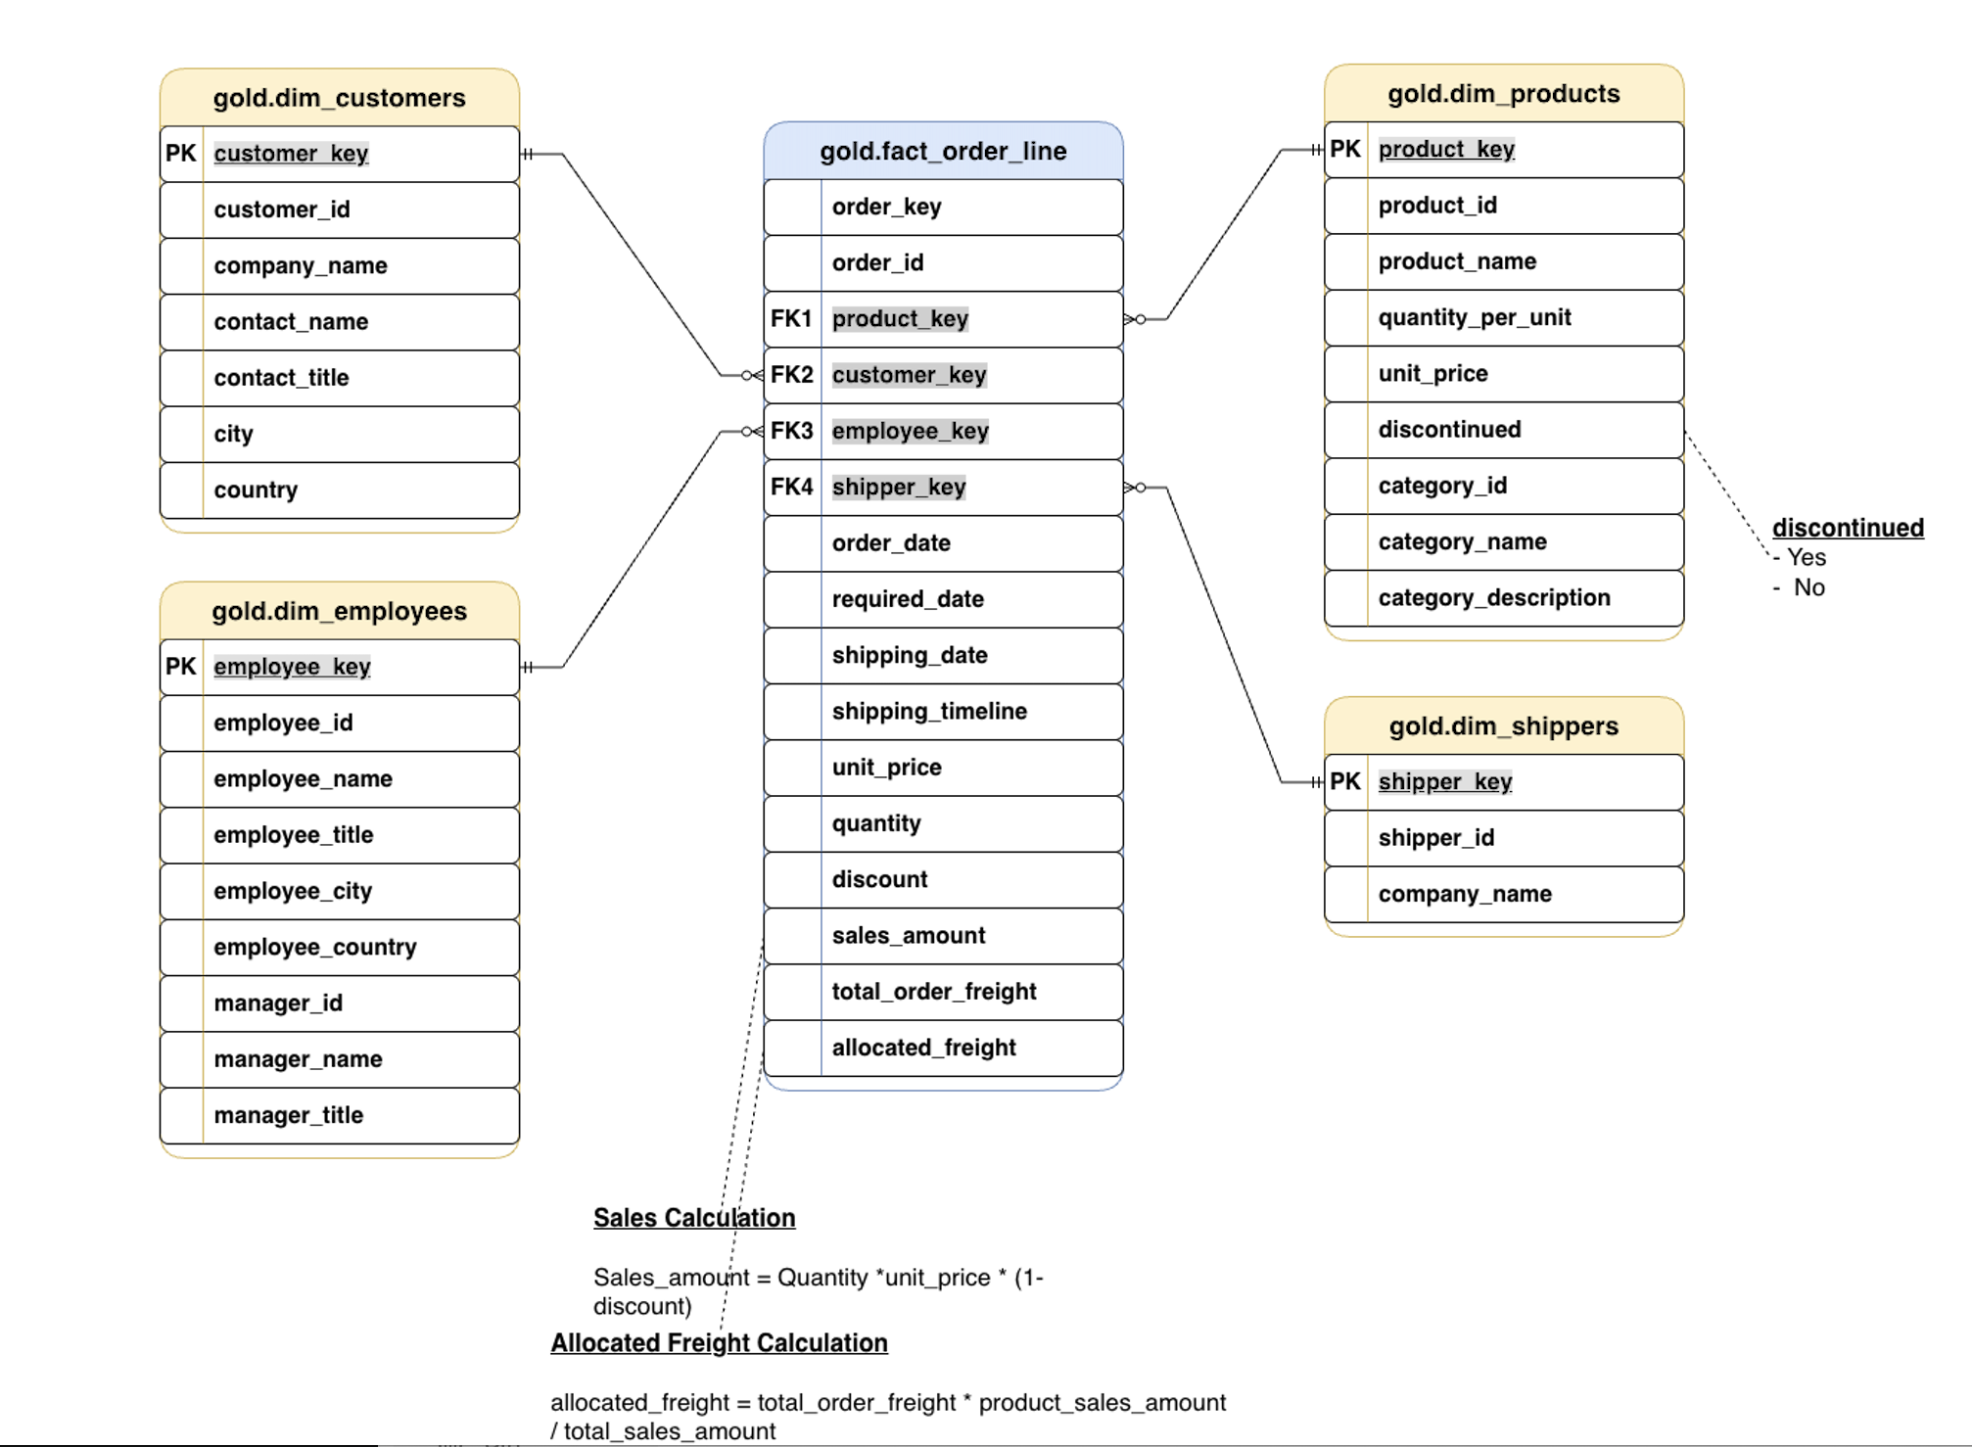
Important: Because the Gold layer uses views, surrogate keys created with ROW_NUMBER() are dynamically generated and may change when the underlying Silver-layer data changes.

